**SVKM’s NMIMS**

**School of Technology Management & Engineering, Navi Mumbai**

A.Y. 2023 - 24

**Course: Database Management Systems**

**Project Report**

|  |  |  |
| --- | --- | --- |
| Program | MBA TECH CE | |
| Semester | IV | |
| Name of the Project: | Air Traffic Control Analysis | |
|  | | |
| Details of Project Members |  |  |
| Batch | Roll No. | Name |
| 2 | A185 | Aryan Gupte |
| 2 | A197 | Pakhi Sharma |
| 2 | A199 | Neil Advani |
| Date of Submission: 30-03-2024 | | |

**Contribution of each project Members:**

|  |  |  |
| --- | --- | --- |
| Roll No. | Name: | Contribution |
| A185 | Aryan Gupte | Designing, creation, implementation of queries, designing ERD |
| A197 | Pakhi Sharma | Designing, Implementation of queries, Report making, Relational model, ERD |
| A199 | Neil Advani | Creating DB, Normalization, Relational Model, Implementation, ERD |

**Project Report**

**Air Traffic Control Analysis**

By

Aryan Gupte (A185)

Pakhi Sharma (A197)

Neil Advani (A199)

**Course: DBMS**

**AY: 2023-24**

**Table of Contents**

|  |  |  |
| --- | --- | --- |
| **Sr no.** | **Topic** | **Page no.** |
| **1** | Storyline | 4 |
| **2** | Components of Database Design | 4 |
| **3** | Entity Relationship Diagram | 5 |
| **4** | Relational Model | 6 |
| **5** | Normalization | 7-9 |
| **6** | SQL Queries | 10 |
| **8** | Project Demonstration | 11-22 |
| **9** | Self-learning beyond classroom | 23 |
| **10** | Learning from the project | 23 |
| **8** | Challenges faced | 24 |
| **9** | Conclusion | 24 |

**I. Storyline**

In the bustling control tower of a major airport, Sarah, a seasoned air traffic controller, faced a daunting challenge. A sudden surge in incoming flights, coupled with adverse weather conditions, threatened to disrupt the carefully orchestrated ballet of aircraft in the sky.

With her keen eyes fixed on the radar screen, Sarah orchestrated a symphony of instructions, guiding planes through crowded airspace with precision and expertise. Each command was a thread in the intricate tapestry of air traffic control, weaving together safety and efficiency in the skies above.

As the storm raged outside, Sarah's calm demeanor and quick thinking ensured that every flight landed safely, despite the chaos. Her dedication and professionalism were the guiding beacon that led countless passengers to their destinations, unfazed by the turbulence below.

In the aftermath, amidst the flurry of accolades and gratitude, Sarah remained humble, knowing that her true reward lay in the knowledge that she had helped countless travelers reach their loved ones, all while keeping the skies safe and secure. This story inspired us to work on this project.

**II. Components of Database Design**

Describe all relationships among various entities. Also, specify the cardinality and participation for all relationships

Flight details (flight no, date, airline, flight category, aircraft type)

Flight departing (departure time, delay departure (Boolean), new departure time, flight no, date)

Flight arriving (arrival time, delay arrival (Boolean), new arrival time, flight no, date)

Cancellation (status (Boolean), flight no, date)

Crew Information (pilot-id, pilot-name, copilot-id, copilot-name, flight no, date)

Ground operation (runway-no, runway-type, parking slot-no, gate-no, terminal-no, flight no, date)

diversion (diverted airport, id, flight no, date)

weather information and fuel availability (id, wind speed, fuel availability, wind direction, condition, visibility, cloud cover)

|  |  |  |  |
| --- | --- | --- | --- |
| Entity 1 | Entity 2 | Relationship | Cardinality |
| Flight details | Diversion | Is diverted | Many to one |
| Flight details | Crew Information | has | One to many |
| Flight details | Ground operations | has | One to many |
| Diversion | Weather Information and Fuel Availability | Is diverted | One to many |
| Flight details | Flight Departing, Flight arriving, Cancellation | ISA | - |

**III. Entity Relationship Diagram**

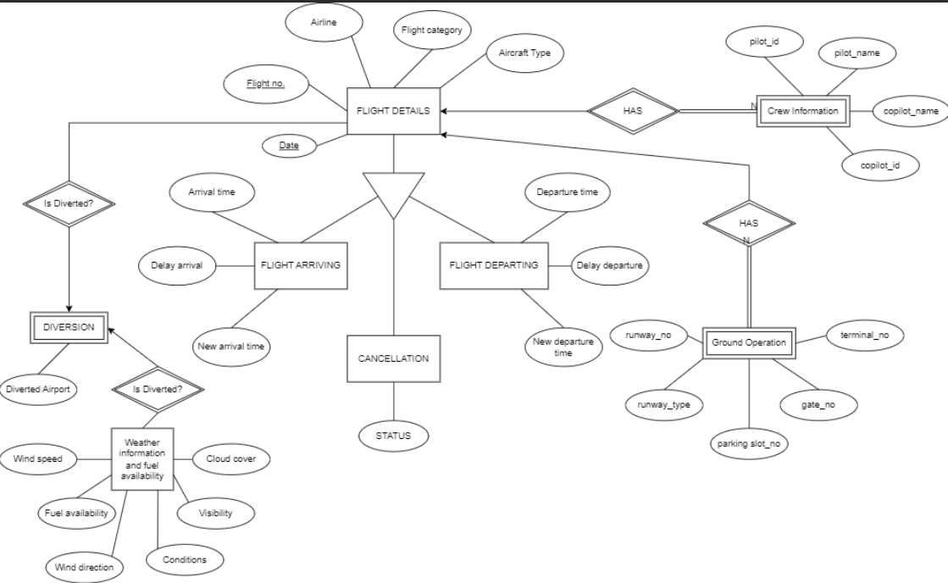

**IV. Relational Model**

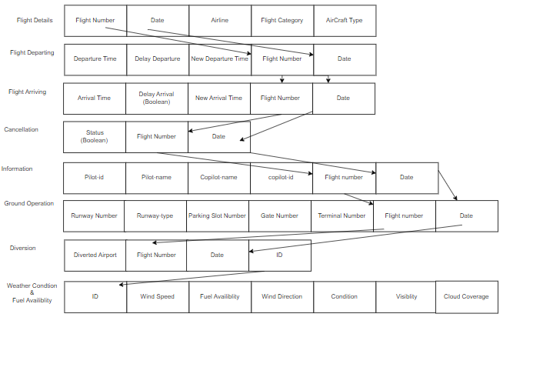

**V. Normalization**

Database Schema :-

Flight details (flight no, date, airline, flight category, aircraft type)

Flight departing (departure time, delay departure (Boolean), new departure time, flight no, date)

Flight arriving (arrival time, delay arrival (Boolean), new arrival time, flight no, date)

Cancellation (status (Boolean), flight no, date)

Crew Information (pilot-id, pilot-name, copilot-id, copilot-name, flight no, date)

Ground operation (runway-no, runway-type, parking slot-no, gate-no, terminal-no, flight no, date)

diversion (diverted airport, id, flight no, date)

weather information and fuel availability (id, wind speed, fuel availability, wind direction, condition, visibility, cloud cover)

To normalize the given database to 3rd Normal Form (3NF), we need to eliminate any transitive dependencies and ensure that each non-prime attribute is fully functionally dependent on the primary key.

First, let's identify the functional dependencies:

1. Flight Details:

- Flight No, Date -> Airline, Flight Category, Aircraft Type

2. Flight Departing:

- Departure Time, Delay Departure, New Departure Time, Flight No, Date -> (No additional functional dependencies)

3. Flight Arriving:

- Arrival Time, Delay Arrival, New Arrival Time, Flight No, Date -> (No additional functional dependencies)

4. Cancellation:

- Status, Flight No, Date -> (No additional functional dependencies)

5. Crew Information:

- Pilot ID, Pilot Name, Co-pilot ID, Co-pilot Name, Flight No, Date -> (No additional functional dependencies)

6. Ground Operation:

- Runway No, Runway Type, Parking Slot No, Gate No, Terminal No, Flight No, Date -> (No additional functional dependencies)

7. Diversion:

- Diverted Airport ID, Flight No, Date -> (No additional functional dependencies)

8. Weather Information and Fuel Availability:

- ID -> Wind Speed, Fuel Availability, Wind Direction, Condition, Visibility, Cloud Cover

Now, let's normalize the database:

First Normal Form (1NF):

- Ensure that each attribute contains atomic values.

- There are no multivalued attributes in the given schema, so it's already in 1NF.

Second Normal Form (2NF):

- Ensure that there are no partial dependencies.

All the tables seem to have single attribute primary keys, so there are no partial dependencies. Therefore, it's already in 2NF.Third Normal Form (3NF):

- Ensure that there are no transitive dependencies.

Based on the identified functional dependencies:

- For Flight Details:

- Flight No, Date -> Airline, Flight Category, Aircraft Type (No transitive dependencies)

- For Weather Information and Fuel Availability:

- ID -> Wind Speed, Fuel Availability, Wind Direction, Condition, Visibility, Cloud Cover (No transitive dependencies)

All other tables seem to have only atomic attributes, and there are no transitive dependencies.

So, the database is already in 3NF.

Tables after normalization :-

1. Flight Details:

- Flight-Details (Flight-No, Date, Airline, Flight-Category, Aircraft-Type)

- Primary Key: (Flight-No, Date)

2. Flight Departing:

- Flight-Departing (Departure-Time, Delay-Departure, New-Departure-Time, Flight-No, Date)

- Foreign Key: (Flight-No, Date) references Flight-Detail (Flight- No, Date)

3. Flight Arriving:

- Flight-Arriving (Arrival-Time, Delay-Arrival, New-Arrival-Time, Flight-No, Date)

- Foreign Key: (Flight-No, Date) references Flight-Details(Flight-No, Date)

4. Cancellation:

- Cancellation (Status, Flight-No, Date)

- Foreign Key: (Flight-No, Date) references Flight-Details(Flight-No, Date)

5. Crew Information:

- Crew-information (Pilot-ID, Pilot-Name, CoPilot-ID, CoPilot-Name, Flight-No, Date)

- Foreign Key: (Flight-No, Date) references Flight-Details(Flight-No, Date)

6. Ground Operation:

- Ground-Operation (Runway-No, Runway-Type, Parking-Slot_No, Gate-No, Terminal-No, Flight-No, Date)

- Foreign Key: (Flight-No, Date) references Flight-Details(Flight-No, Date)

7. Diversion:

- Diversion (Diverted-Airport-ID, Flight-No, Date)

- Foreign Key: (Flight-No, Date) references Flight-Details(Flight-No, Date)

8. Weather Information and Fuel Availability:

Weather-Fuel-Info (ID, Wind-Speed, Fuel-Availability, Wind-Direction, Condition, Visibility, Cloud-Cover

- Primary Key: ID

**VI. SQL Queries**

1. Find out the flights that are departing.
2. Find out the flights that are arriving.
3. Find out pilot id, pilot name, copilot id and co pilot for flights arriving.
4. Find out pilot id, pilot name, copilot id and co pilot for flights departing.
5. Find out flight no, airline, flight category, and aircraft type for flights arriving.
6. Find out flight no, airline, flight category, and aircraft type for flights departing.
7. Find out flights that are delayed for departure, their previous departure time, by how many hours/min the flight is delayed and new departure time.
8. Find out flights that are delayed for arrival, their previous arrival time, by how many hours/min the flight is delayed and new arrival time.
9. Find out flights that are diverted and also diverted airport name.
10. If diverted, find out the weather information and fuel availability of that flight.
11. Find out the flights that are cancelled.
12. Find out runway no, runway type, parking slot no, gate no and terminal for flights arriving.
13. Find out runway no, runway type, parking slot no, gate no and terminal for flights departing.
14. Retrieve Flight Information for Airline ‘Emirates’.
15. Retrieve crew information for Airline ‘Singapore Airline’.
16. Retrieve weather condition and fuel availability for a specific condition.
17. Updating departure time for a particular departing flight.
18. Update crew information of a specific flight.
19. Retrieving flight information for a particular diverted flight.
20. Updating diversion information for a specific flight number.

**VI. Project demonstration**

Creating A Databaase

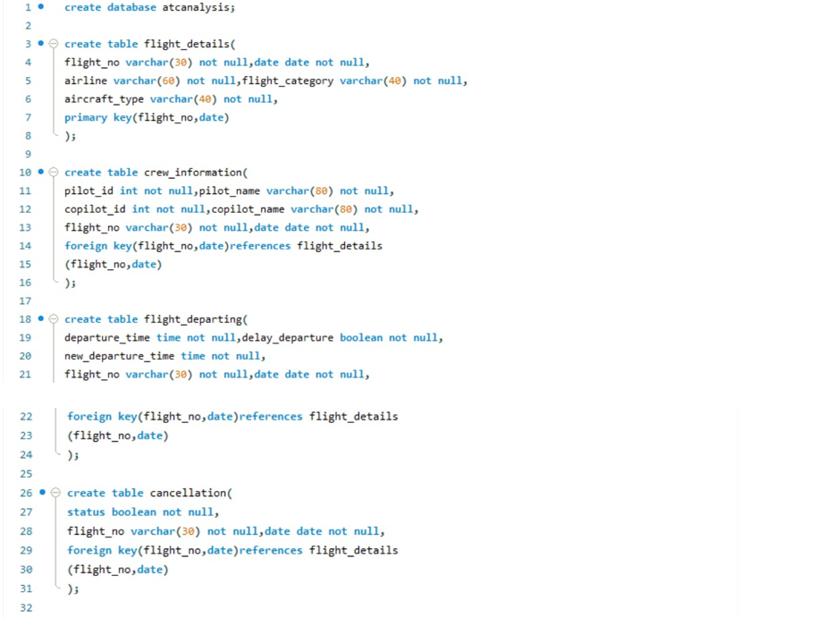

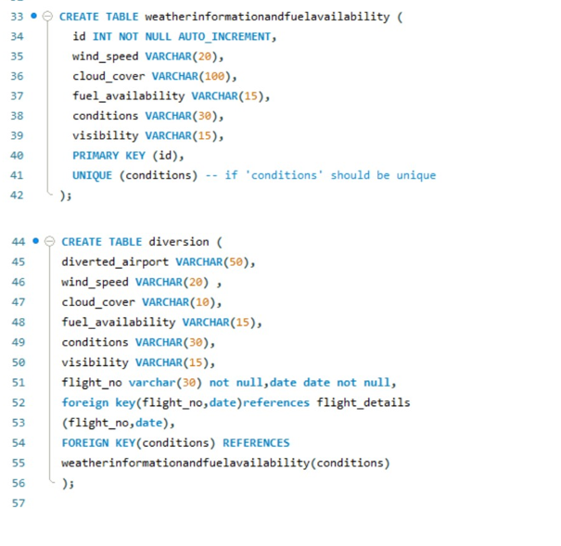

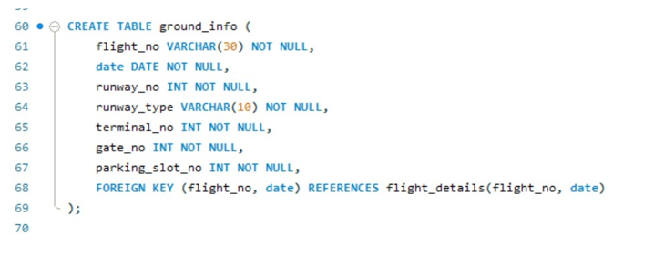

2. Inserting Value in the Respective Tables

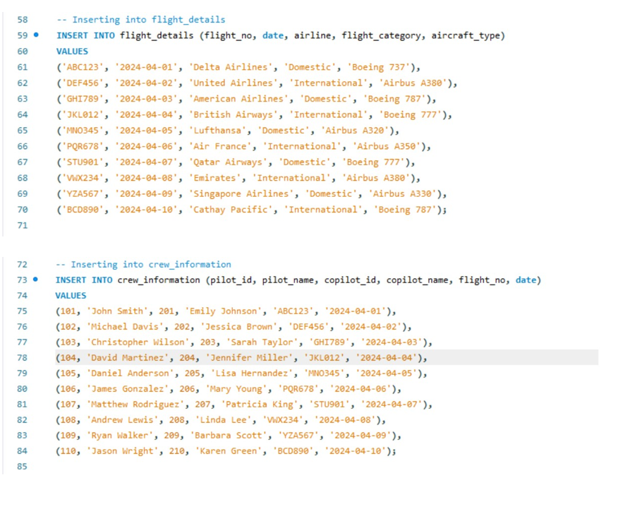

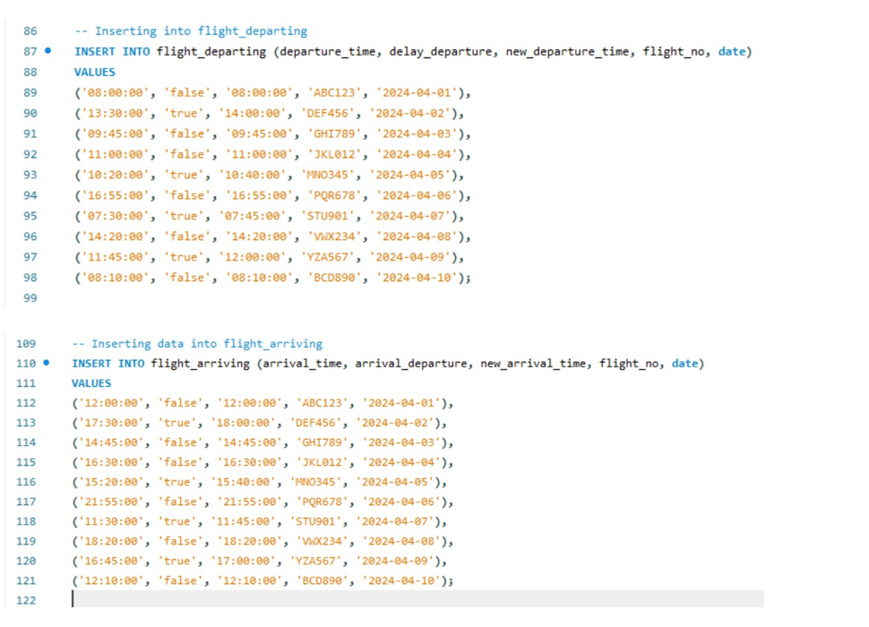

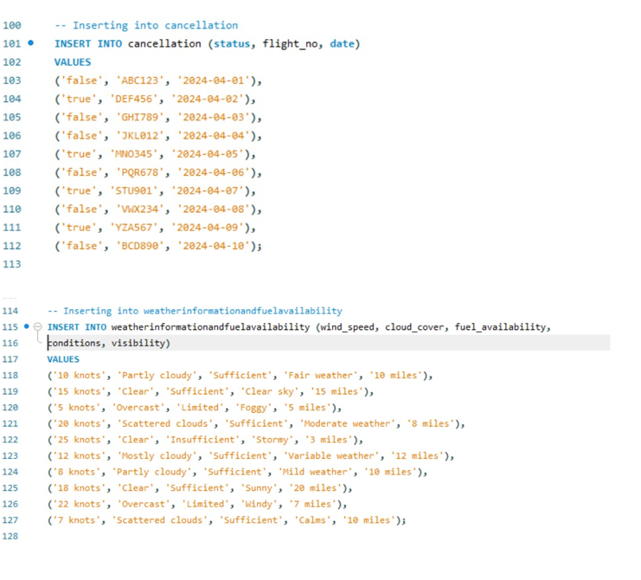

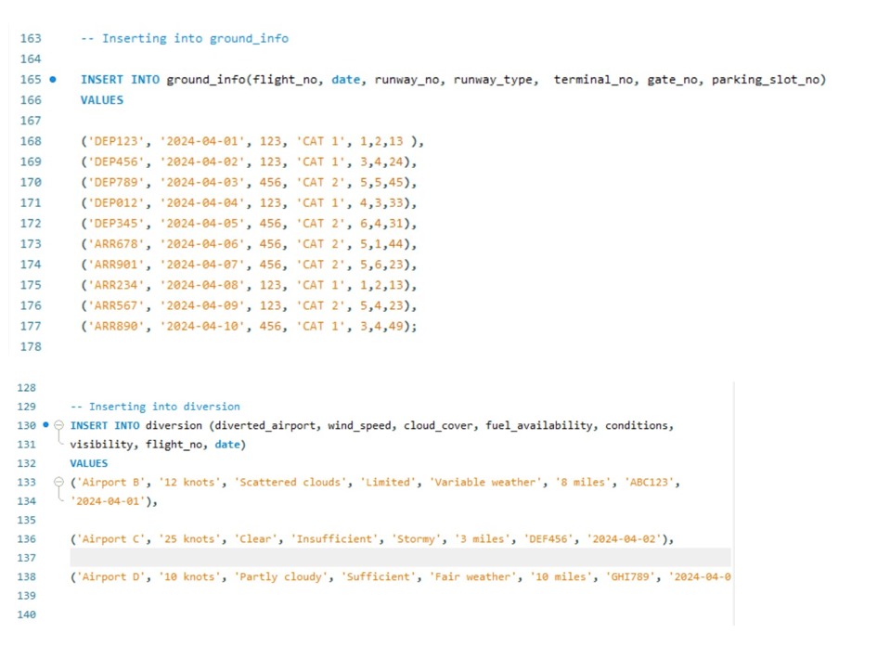

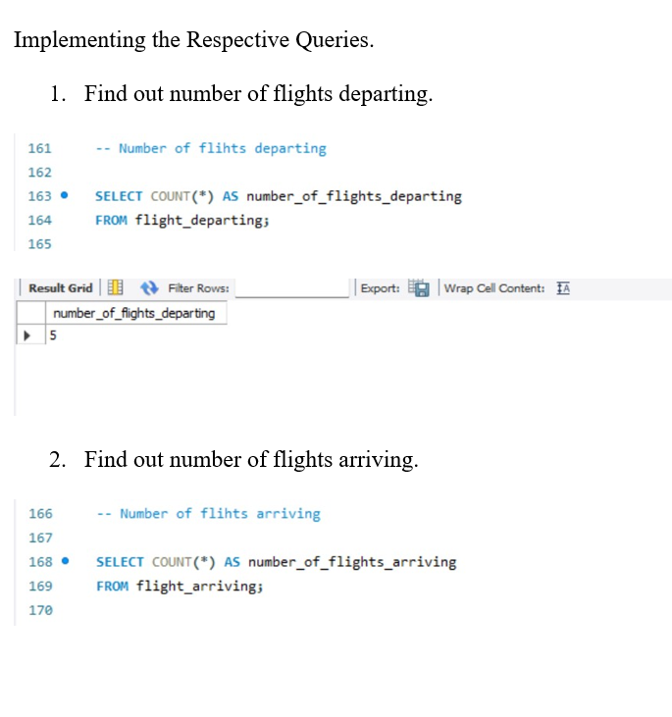

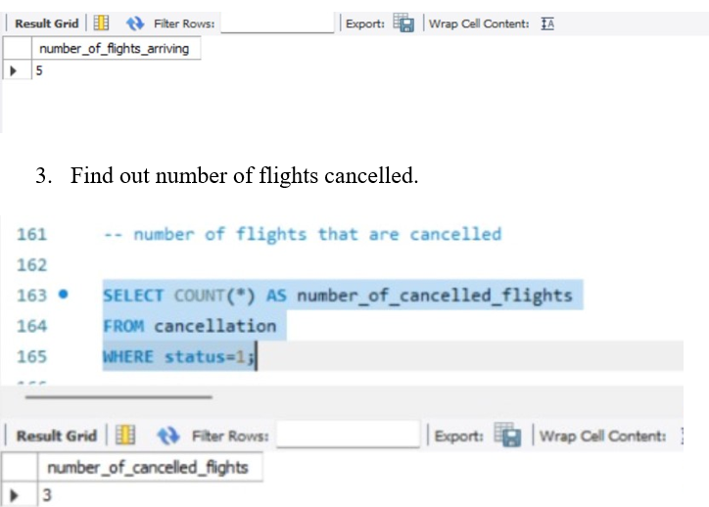

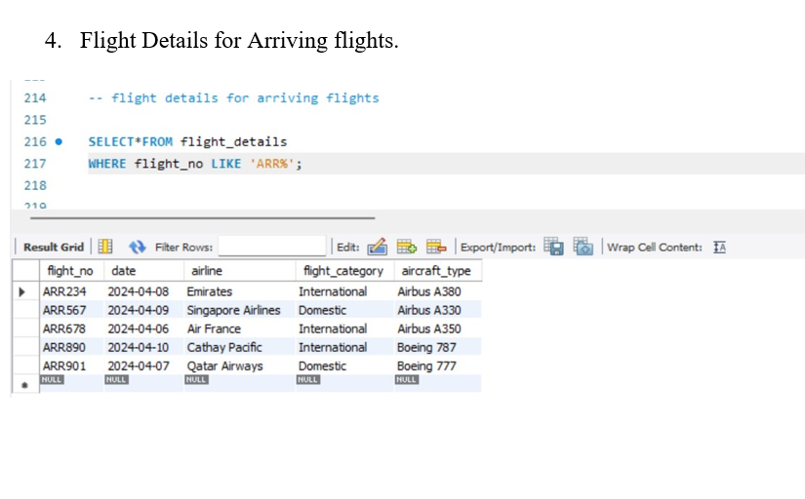

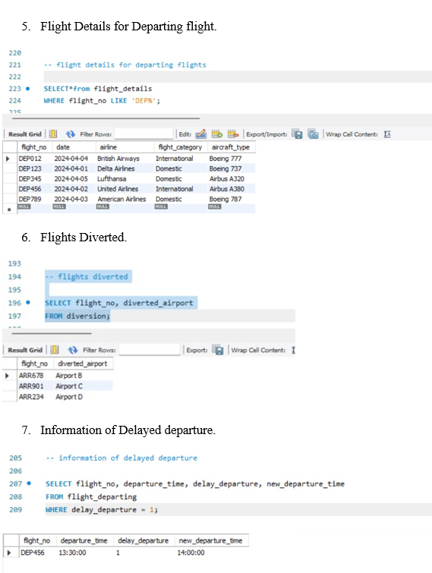

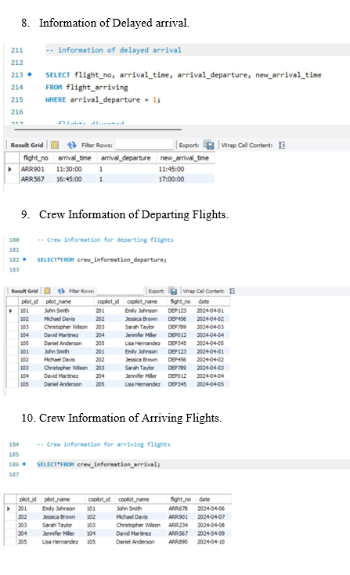

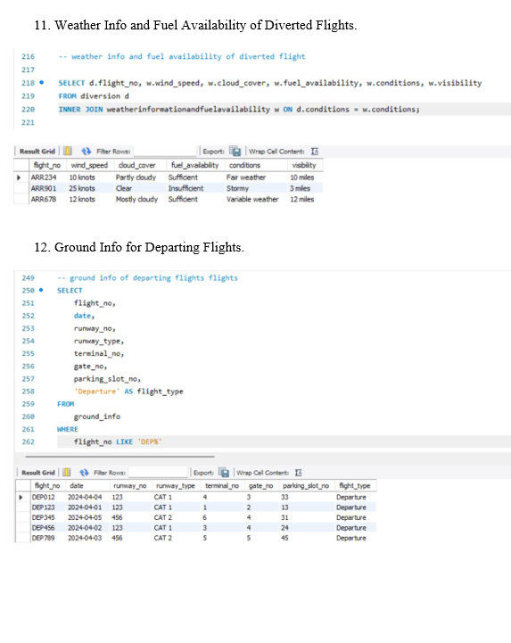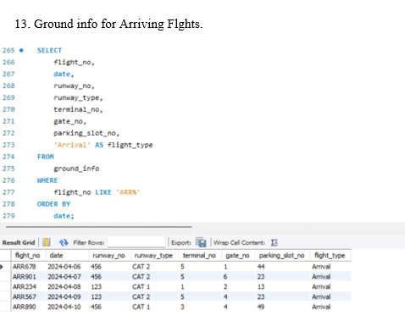

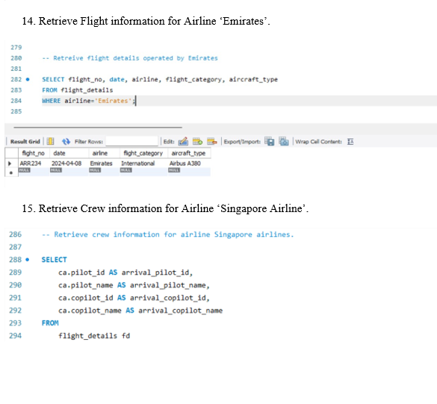

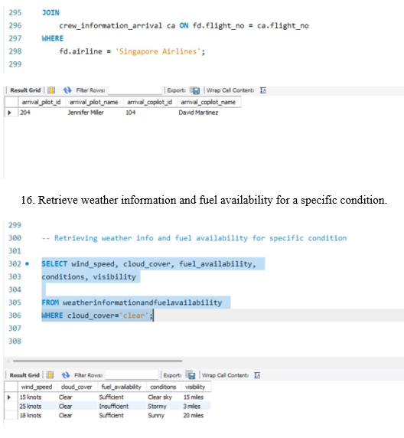

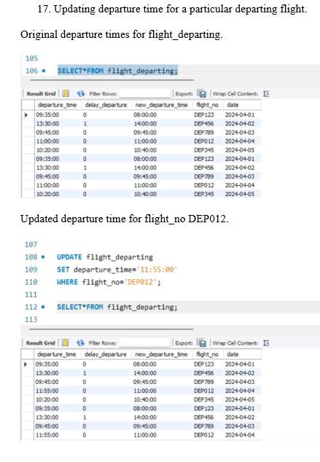

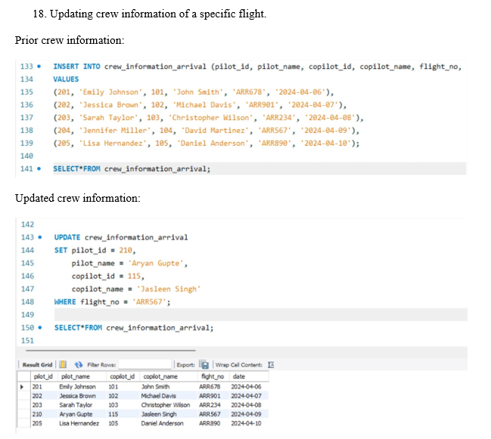

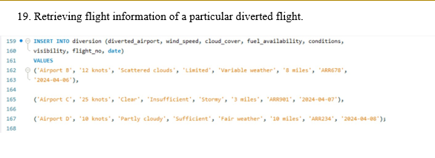

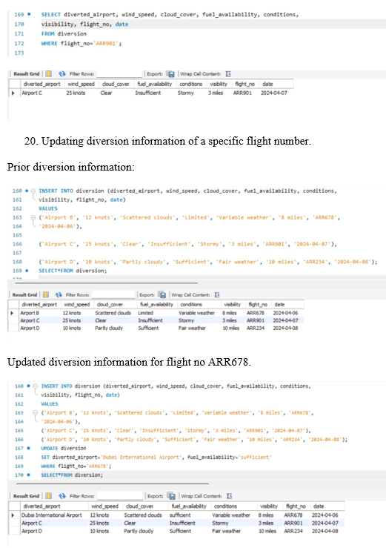

**VII. Self -Learning beyond classroom**

Through self-learning and exploration beyond the confines of the classroom, We not only expanded our technical expertise in DBMS but also cultivated a deeper appreciation for the practical applications and complexities of database management in real-world scenarios. These newfound skills and insights have not only enriched our academic journey but also prepared us for future challenges and opportunities in the field of data management and analysis.

:

**VIII. Learning from the Project**

The journey of working on the Air Traffic Control Analysis project using MySQL has been a transformative learning experience, providing valuable insights into both technical and practical aspects of database management and analysis in the context of aviation operations. The following are some key takeaways from the project:

1. Understanding Domain-specific Challenges: One of the most significant learnings from this project was gaining a deep understanding of the unique challenges and complexities inherent in air traffic control operations

2. Database Design and Optimization: Developing the database schema for storing and managing air traffic data required careful consideration of data structures, relationships, and performance optimization techniques.

3. Problem-solving and Adaptability: Throughout the project, we encountered various technical challenges and unforeseen obstacles that required creative problem-solving and adaptability.

4. Security and Compliance Considerations: The project underscored the paramount importance of security and compliance in handling sensitive air traffic data.

The Air Traffic Control Analysis project using MySQL has not only deepened our understanding of database management principles but also provided practical insights into the application of DBMS in real-world scenarios. The skills, knowledge, and experiences gained from this project will undoubtedly serve as a solid foundation for future endeavors in database management, data analysis, and aviation technology.

**IX. Challenges Faced**

The development and implementation of the Air Traffic Control Analysis project using MySQL presented several challenges that required careful navigation and problem-solving. The following are some of the key challenges encountered during the project:

1.Data Integration Complexity: Each data source had its own format, schema, and update frequency, requiring extensive data preprocessing and transformation to ensure consistency and compatibility within the database.

2. Testing and Validation: Testing the database solution to ensure data accuracy, reliability, and performance

3. Time Management: Managing time effectively to meet project deadlines and balance academic coursework and other commitments

Despite the challenges encountered, the project team remained resilient and adaptive, ultimately achieving success in delivering a robust and scalable database solution for air traffic control analysis. Each challenge served as a valuable learning opportunity, contributing to the team's growth and expertise in database management and aviation technology.

**X. Conclusion**

In conclusion, the project on air traffic control analysis using MySQL has been a journey of exploration, learning, and growth. Through this project, we embarked on a mission to leverage database management techniques to analyze and optimize air traffic operations, aiming to enhance safety, efficiency, and reliability in aviation.

Key Takeaways:

1. Technical Proficiency: The project has enhanced our proficiency in database management concepts

2. Collaboration and Communication: Working collaboratively as a team has fostered effective communication.

3. Continuous Learning: The project has ignited our passion for continuous learning and exploration.

4. Problem-solving Skills: By addressing technical challenges and overcoming obstacles in database design and implementation

Overall, the project on air traffic control analysis using MySQL has been an enriching and rewarding experience, equipping us with the skills, knowledge, and confidence to embark on future endeavors in the dynamic field of database management and aviation technology.

.